E
E
St. Lucia  2025  The circle of life  www.legnani.eu/SLucia by joe © | 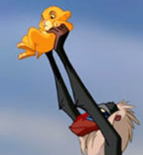  And one day you realize that you exist, that you are part of the world. Not by your own will, and you ask yourself who knows... are we here by whose will? (The Lion King, Italian version) | A child doesn't know why (s)he exists…, how to live…  but learns from his/her mother, the mother of the mother, and maybe the mother of the mother, of the mother... | 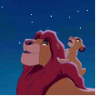  They'll always be there to guide you.  And I'll be there too.  The great kings of the past look down on us from those stars.  (The Lion King)  One day the sun will set on me and rise with you.
E
It's the passing of knowledge from one generation to the next.  With its difficulties.  In one direction and the other. | It's from childhood that we learn how growing up (Italian Scout saying)  All grown-ups were once children, but few of them remember it.  (The Little Prince) | A mother, a father, passes on to their children,  the children of the children, of the children...  …if (s)he has an open heart(s)he receives much more from them | 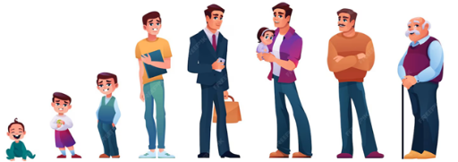  It is the circle of life that can leave the world better than you found it. | E | nnnnnnnn  nnnnnnnnnnnnnnnn

E
E
St. Lucia  2025  The circle of life  www.legnani.eu/SLucia by joe © | And one day you realize that you exist, that you are part of the world. Not by your own will, and you ask yourself who knows... are we here by whose will? (The Lion King, Italian version) | A child doesn't know why (s)he exists…, how to live…  but learns from his/her mother, the mother of the mother, and maybe the mother of the mother, of the mother... | They'll always be there to guide you.  And I'll be there too.  The great kings of the past look down on us from those stars.  (The Lion King)  One day the sun will set on me and rise with you.
E
It's the passing of knowledge from one generation to the next.  With its difficulties.  In one direction and the other. | It's from childhood that we learn how growing up (Italian Scout saying)  All grown-ups were once children, but few of them remember it.  (The Little Prince) | A mother, a father, passes on to their children,  the children of the children, of the children...  …if (s)he has an open heart(s)he receives much more from them | It is the circle of life that can leave the world better than you found it. | E | nnnnnnnn  nnnnnnnnnnnnnnnn

E
E
St. Lucia  2025  The circle of life  www.legnani.eu/SLucia by joe © | And one day you realize that you exist, that you are part of the world. Not by your own will, and you ask yourself who knows... are we here by whose will? (The Lion King, Italian version) | A child doesn't know why (s)he exists…, how to live…  but learns from his/her mother, the mother of the mother, and maybe the mother of the mother, of the mother... | They'll always be there to guide you.  And I'll be there too.  The great kings of the past look down on us from those stars.  (The Lion King)  One day the sun will set on me and rise with you.
E
It's the passing of knowledge from one generation to the next.  With its difficulties.  In one direction and the other. | It's from childhood that we learn how growing up (Italian Scout saying)  All grown-ups were once children, but few of them remember it.  (The Little Prince) | A mother, a father, passes on to their children,  the children of the children, of the children...  …if (s)he has an open heart(s)he receives much more from them | It is the circle of life that can leave the world better than you found it. | E | nnnnnnnn  nnnnnnnnnnnnnnnn

