E
E
S. Lucia  2022  …  www.legnani.eu/SLucia by joe © | 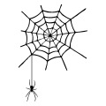  A web by the bed.  Woven by a magic spider. |   A web that filters dreams by imprisoning the bad ones and freeing the good ones. | 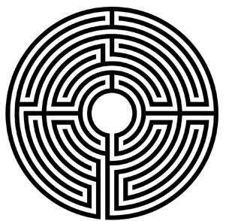  A maze of paths tied together by knots.

E
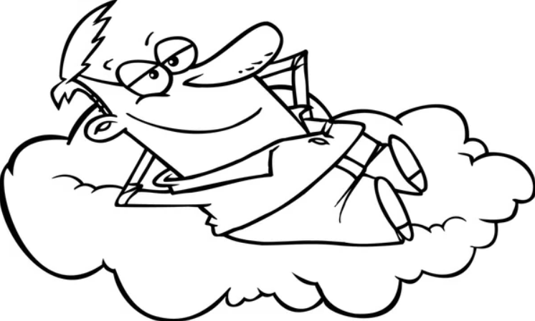  Among these a path to connect Earth and sky. | 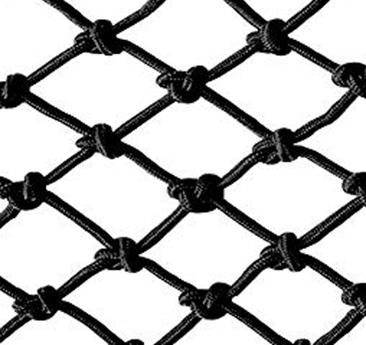  At each intersection you have a knot to overcome, a choice to make. | And dreams guide you,  you dominate them or you let them dominate you…  …it’s your choice. |   Let yourself slide down, or choose to climb to infinity. | E

E
E
S. Lucia  2022  …  www.legnani.eu/SLucia by joe © | A web by the bed.  Woven by a magic spider. | A web that filters dreams by imprisoning the bad ones and freeing the good ones. | A maze of paths tied together by knots.

E
Among these a path to connect Earth and sky. | At each intersection you have a knot to overcome, a choice to make. | And dreams guide you,  you dominate them or you let them dominate you…  …it’s your choice. | Let yourself slide down, or choose to climb to infinity. | E

E
E
S. Lucia  2022  …  www.legnani.eu/SLucia by joe © | A web by the bed.  Woven by a magic spider. | A web that filters dreams by imprisoning the bad ones and freeing the good ones. | A maze of paths tied together by knots.
E
Among these a path to connect Earth and sky. | At each intersection you have a knot to overcome, a choice to make. | And dreams guide you,  you dominate them or you let them dominate you…  …it’s your choice. | Let yourself slide down, or choose to climb to infinity. | E

