E
E
S. Lucia  2018  the heat…  www.legnani.eu/SLucia by joe © | There is the heat of the sun, of the fire and of the heart. | Too much, can burn you,  too little makes you freeze | 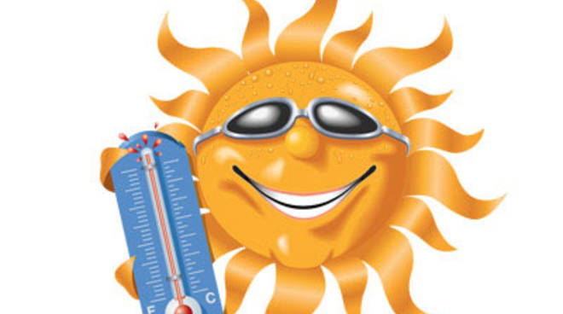  The sun gives it to you for free, and does not ask for anything in return

E
E
S. Lucia  2018  the heat…  www.legnani.eu/SLucia by joe © | There is the heat of the sun, of the fire and of the heart. | Too much, can burn you,  too little makes you freeze | The sun gives it to you for free, and does not ask for anything in return | Una folla di pezzi, sperduti e irricono-scibili,  che cercano accoglienza

E
E
S. Lucia  2018  the heat…  www.legnani.eu/SLucia by joe © | There is the heat of the sun, of the fire and of the heart. | Too much, can burn you,  too little makes you freeze | The sun gives it to you for free, and does not ask for anything in return | Una folla di pezzi, sperduti e irricono-scibili,  che cercano accoglienza

E
E
S. Lucia  2018  the heat…  www.legnani.eu/SLucia by joe © | There is the heat of the sun, of the fire and of the heart. | Too much, can burn you,  too little makes you freeze | The sun gives it to you for free, and does not ask for anything in return | Una folla di pezzi, sperduti e irricono-scibili,  che cercano accoglienza

E
E
S. Lucia  2018  the heat…  www.legnani.eu/SLucia by joe © | There is the heat of the sun, of the fire and of the heart. | Too much, can burn you,  too little makes you freeze | The sun gives it to you for free, and does not ask for anything in return | Una folla di pezzi, sperduti e irricono-scibili,  che cercano accoglienza

E
E
E
E
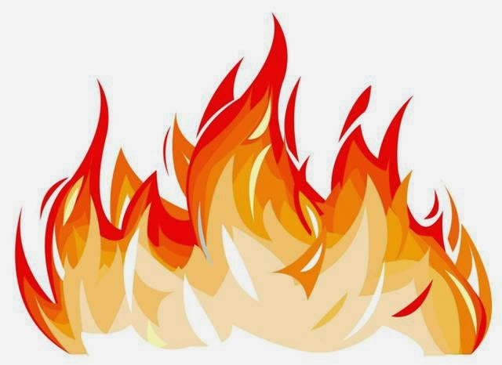  The fire consumes you |   You may give the heat of your heart without losing what is in you, you can receive it without taking it away from who gives it to you | More people close to each other warm each other up.   | But..  we must know how to give it,  you must know how to receive it.

E
E
The fire consumes you | You may give the heat of your heart without losing what is in you, you can receive it without taking it away from who gives it to you | More people close to each other warm each other up. | But..  we must know how to give it,  you must know how to receive it.

E
E
The fire consumes you | You may give the heat of your heart without losing what is in you, you can receive it without taking it away from who gives it to you | More people close to each other warm each other up. | But..  we must know how to give it,  you must know how to receive it.

E
E

The fire consumes you | You may give the heat of your heart without losing what is in you, you can receive it without taking it away from who gives it to you | More people close to each other warm each other up. | But..  we must know how to give it,  you must know how to receive it.

The fire consumes you | You may give the heat of your heart without losing what is in you, you can receive it without taking it away from who gives it to you | More people close to each other warm each other up. | But..  we must know how to give it,  you must know how to receive it.

