E
E
S. Lucia  2016  www.legnani.eu/SLucia by joe © | A storm,  that takes you on the road.  A storm that enters in your heart when you feel  ignored or abandoned, and the forces are no longer sufficient.  It was a night, it was raining  and a strong wind was blowing  imagine what  a great torment  for an alpine  who had to stay at watch  [From ancient Italian alpine song]   |  | And hope,  last goddess,  it is preparing  to leave you.  And you feel a  strong desire  to close your eyes.  Forever.  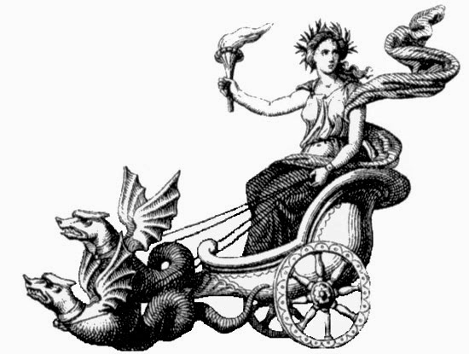

E
E
S. Lucia  2016  www.legnani.eu/SLucia by joe © | A storm,  that takes you on the road.  A storm that enters in your heart when you feel  ignored or abandoned, and the forces are no longer sufficient.  It was a night, it was raining  and a strong wind was blowing  imagine what  a great torment  for an alpine  who had to stay at watch  [From ancient Italian alpine song] |  | And hope,  last goddess,  it is preparing  to leave you.  And you feel a  strong desire  to close your eyes.  Forever.

E
E
S. Lucia  2016  www.legnani.eu/SLucia by joe © | A storm,  that takes you on the road.  A storm that enters in your heart when you feel  ignored or abandoned, and the forces are no longer sufficient.  It was a night, it was raining  and a strong wind was blowing  imagine what  a great torment  for an alpine  who had to stay at watch  [From ancient Italian alpine song] |  | And hope,  last goddess,  it is preparing  to leave you.  And you feel a  strong desire  to close your eyes.  Forever.

E
E
S. Lucia  2016  www.legnani.eu/SLucia by joe © | A storm,  that takes you on the road.  A storm that enters in your heart when you feel  ignored or abandoned, and the forces are no longer sufficient.  It was a night, it was raining  and a strong wind was blowing  imagine what  a great torment  for an alpine  who had to stay at watch  [From ancient Italian alpine song] |  | And hope,  last goddess,  it is preparing  to leave you.  And you feel a  strong desire  to close your eyes.  Forever.

E
E
S. Lucia  2016  www.legnani.eu/SLucia by joe © | A storm,  that takes you on the road.  A storm that enters in your heart when you feel  ignored or abandoned, and the forces are no longer sufficient.  It was a night, it was raining  and a strong wind was blowing  imagine what  a great torment  for an alpine  who had to stay at watch  [From ancient Italian alpine song] |  | And hope,  last goddess,  it is preparing  to leave you.  And you feel a  strong desire  to close your eyes.  Forever.
E
E
E
E
A Voice speaks to you: I set my bow in the cloud, as a sign of the covenant between me and the Earth. ... And I will look at it and I will remember the everlasting covenant between me and every living creature of every kind ...
[Genesis chapter 9]
But if you half-open them,  if you peek ...  a small glow makes its way,  and the great sign appears.  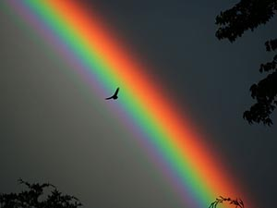 | When you were a child they told you:  where it ends, ...  where the roots are, ...  the dwarfs have hidden a pot of gold coins.  The corner of your  mouth softens.   | His voice comes to you through the smile of a neighbor, from him, her.  Its the rain that goes,  and the serene returns.  isbn 979-12-200-1548-6 | 

E
E
But if you half-open them,  if you peek ...  a small glow makes its way,  and the great sign appears. | When you were a child they told you:  where it ends, ...  where the roots are, ...  the dwarfs have hidden a pot of gold coins.  The corner of your  mouth softens. | His voice comes to you through the smile of a neighbor, from him, her.  Its the rain that goes,  and the clear sky returns.  isbn 979-12-200-1548-6  A Voice speaks to you: I set my bow in the cloud, as a sign of the covenant between me and the Earth. ... And I will look at it and I will remember the everlasting covenant between me and every living creature of every kind ...  [Genesis chapter 9]

A Voice speaks to you: I set my bow in the cloud, as a sign of the covenant between me and the Earth. ... And I will look at it and I will remember the everlasting covenant between me and every living creature of every kind ...
[Genesis chapter 9]
E
E
But if you half-open them,  if you peek ...  a small glow makes its way,  and the great sign appears. | When you were a child they told you:  where it ends, ...  where the roots are, ...  the dwarfs have hidden a pot of gold coins.  The corner of your  mouth softens. | His voice comes to you through the smile of a neighbor, from him, her.  Its the rain that goes,  and the clear sky returns.  isbn 979-12-200-1548-6

E
E
A Voice speaks to you: I set my bow in the cloud, as a sign of the covenant between me and the Earth. ... And I will look at it and I will remember the everlasting covenant between me and every living creature of every kind ...
[Genesis chapter 9]

But if you half-open them,  if you peek ...  a small glow makes its way,  and the great sign appears. | When you were a child they told you:  where it ends, ...  where the roots are, ...  the dwarfs have hidden a pot of gold coins.  The corner of your  mouth softens. | His voice comes to you through the smile of a neighbor, from him, her.  Its the rain that goes,  and the clear sky returns.  isbn 979-12-200-1548-6

A Voice speaks to you: I set my bow in the cloud, as a sign of the covenant between me and the Earth. ... And I will look at it and I will remember the everlasting covenant between me and every living creature of every kind ...
[Genesis chapter 9]

But if you half-open them,  if you peek ...  a small glow makes its way,  and the great sign appears. | When you were a child they told you:  where it ends, ...  where the roots are, ...  the dwarfs have hidden a pot of gold coins.  The corner of your  mouth softens. | His voice comes to you through the smile of a neighbor, from him, her.  Its the rain that goes,  and the clear sky returns.  isbn 979-12-200-1548-6

