E
E
S. Lucia  2015  www.legnani.eu/SLucia by joe © | 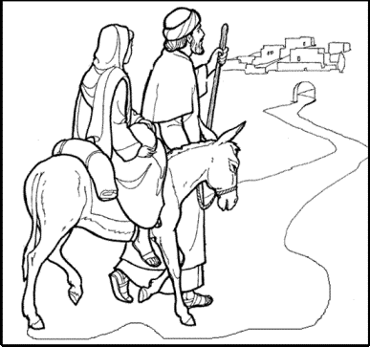  Life is like a journey,  with a beginning and one end. | 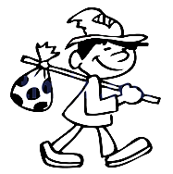  Everybody, when traveling, brings some luggage.  A sack may serve as luggage | A suck may be full with a treasure or garbage.  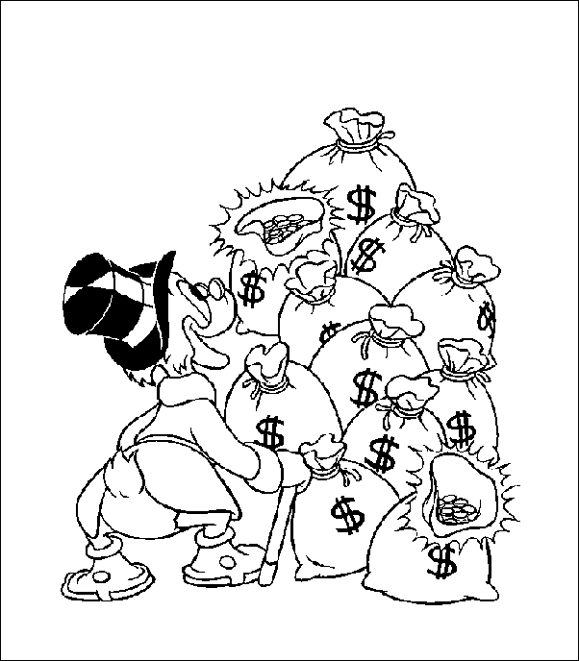  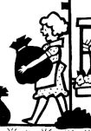

E
E
S. Lucia  2015  www.legnani.eu/SLucia by joe © | Life is like a journey,  with a beginning and one end. | Everybody, when traveling, brings some luggage.  A sack may serve as luggage.  . | A suck may be full with a treasure or garbage.

E
E
S. Lucia  2015  www.legnani.eu/SLucia by joe © | Life is like a journey,  with a beginning and one end. | Everybody, when traveling, brings some luggage.  A sack may serve as luggage.  . | A suck may be full with a treasure or garbage.

E
E
S. Lucia  2015  www.legnani.eu/SLucia by joe © | Life is like a journey,  with a beginning and one end. | Everybody, when traveling, brings some luggage.  A sack may serve as luggage.  . | A suck may be full with a treasure or garbage.

E
E
S. Lucia  2015  www.legnani.eu/SLucia by joe © | Life is like a journey,  with a beginning and one end. | Everybody, when traveling, brings some luggage.  A sack may serve as luggage | A suck may be full with a treasure or garbage.

E
E
E
E
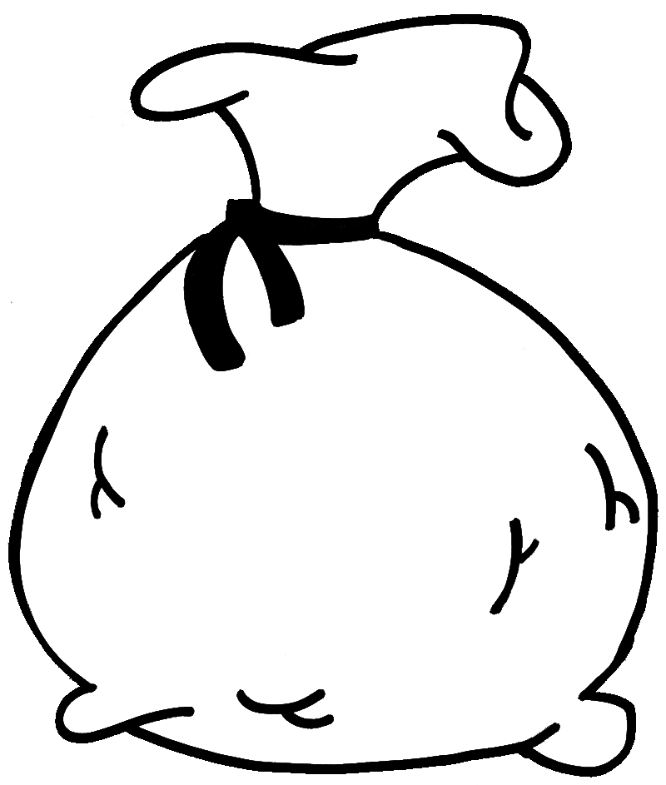  Life is like a sack. | In your sack you found what was left by the ones who preceded you. | In your sack, you may put what you want, what you need during your walk and that you will leave to whom who follow you.  Your joy depends on this.  And your joy cannot be separated from that of your travel mates. | 

E
E
Life is like a sack. | In your sack you found what was left by the ones who preceded you.  . | In your sack, you may put what you want, what you need during your walk and that you will leave to whom who follow you.  Your joy depends on this.  And your joy cannot be separated from that of your travel mates.

E
E
Life is like a sack. | In your sack you found what was left by the ones who preceded you. | In your sack, you may put what you want, what you need during your walk and that you will leave to whom who follow you.  Your joy depends on this.  And your joy cannot be separated from that of your travel mates.

E
E
Life is like a sack.  . | In your sack you found what was left by the ones who preceded you. | And your joy cannot be separated from that of your travel mates.  In your sack, you may put what you want, what you need during your walk and that you will leave to whom who follow you.  Your joy depends on this.

Life is like a sack. | In your sack you found what was left by the ones who preceded you. | And your joy cannot be separated from that of your travel mates.  In your sack, you may put what you want, what you need during your walk and that you will leave to whom who follow you.  Your joy depends on this.

