S. Lucia  2014  www.legnani.eu/SLucia by joe © |  |  |   …and the words may travel, crossing mountains and oceans

E
E  E  E  E  E  E  S. Lucia  2014  www.legnani.eu/SLucia by joe © |  |  | …and the words may travel, crossing mountains and oceans

E
S. Lucia  2014  www.legnani.eu/SLucia by joe © |  |  | …and the words may travel, crossing mountains and oceans

E
S. Lucia  2014  www.legnani.eu/SLucia by joe © |  |  | …and the words may travel, crossing mountains and oceans

E
S. Lucia  2014  www.legnani.eu/SLucia by joe © |  |  | …and the words may travel, crossing mountains and oceans

E
E
E
E
...they may touch hearts, and switch on smiles. | 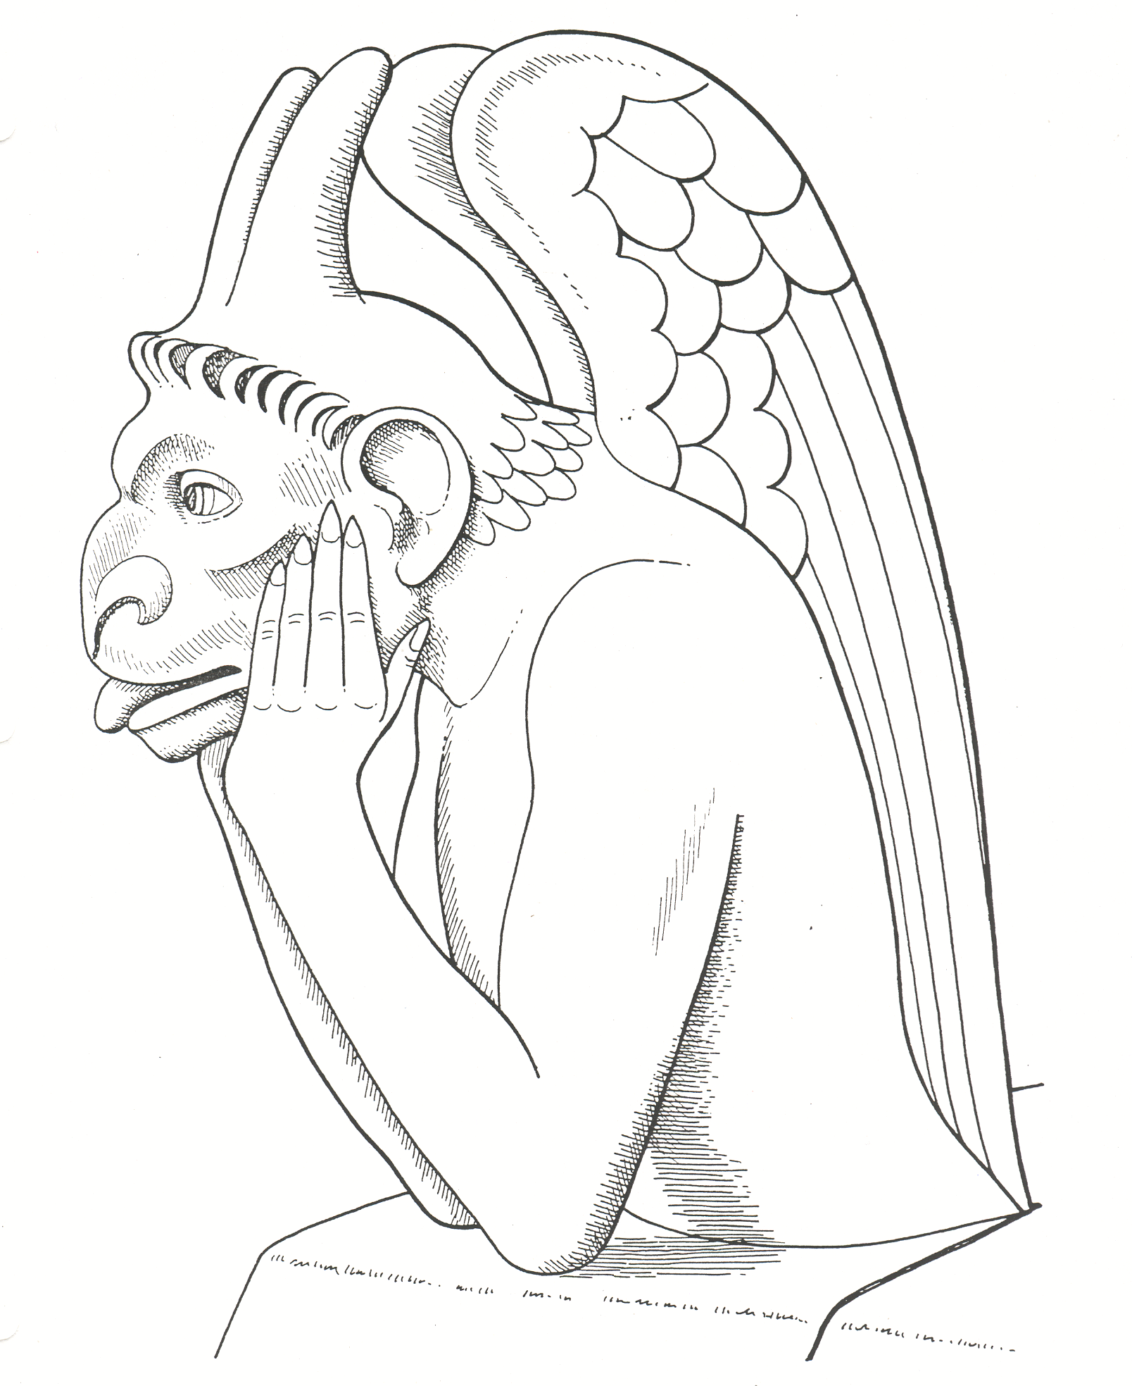  Willingness is required when reading, and inspiration when writing. |   …someone may be waiting for your words.  Do not let  him/her wait.  And inspiration and joy are also required when choosing the writing paper! | 

E
E
...they may touch hearts, and switch on smiles. | Willingness is required when reading, and inspiration when writing. | …someone may be waiting for your words.  Do not let  him/her wait.  And inspiration and joy are also required when choosing the writing paper!

E
E
...they may touch hearts, and switch on smiles. | Willingness is required when reading, and inspiration when writing. | …someone may be waiting for your words.  Do not let  him/her wait.  And inspiration and joy are also required when choosing the writing paper!

E
E
...they may touch hearts, and switch on smiles. | Willingness is required when reading, and inspiration when writing. | …someone may be waiting for your words.  Do not let  him/her wait.  And inspiration and joy are also required when choosing the writing paper!

...they may touch hearts, and switch on smiles. | Willingness is required when reading, and inspiration when writing. | …someone may be waiting for your words.  Do not let  him/her wait.  And inspiration and joy are also required when choosing the writing paper!

