An house, a skyscraper, a hut.  They have  something in common:  You can watch peering from behind a courting;  you can lean out, observing and being observed.  S. Lucia  2011  www.legnani.eu/SLucia by joe © |  | … doors and windows.  You can enter.  you can exit | E

An house, a skyscraper, a hut.  They have  something in common:  You can watch peering from behind a courting;  you can lean out, observing and being observed.  S. Lucia  2011  www.legnani.eu/SLucia by joe © |  | … doors and windows.  You can enter.  you can exit | E

An house, a skyscraper, a hut.  They have  something in common:  You can watch peering from behind a courting;  you can lean out, observing and being observed.  S. Lucia  2011  www.legnani.eu/SLucia by joe © |  | … doors and windows.  You can enter.  you can exit | E

An house, a skyscraper, a hut.  They have  something in common:  You can watch peering from behind a courting;  you can lean out, observing and being observed.  S. Lucia  2011  www.legnani.eu/SLucia by joe © |  | … doors and windows.  You can enter.  you can exit | E

An house, a skyscraper, a hut.  They have  something in common:  You can watch peering from behind a courting;  you can lean out, observing and being observed.  S. Lucia  2011  www.legnani.eu/SLucia by joe © |  | … doors and windows.  You can enter.  you can exit | E

A way to communicate,  to watch from different points of view,  to meet and cooperate.  Eyes, hears, mouth:  the doors and windows of your heart:  print a nice smile on them!  ...  Never too open, never too close.  Opening them, wide? Closing, barring them?  A windows with curtains and flowers?  A window with bars?  E  . |  |  | 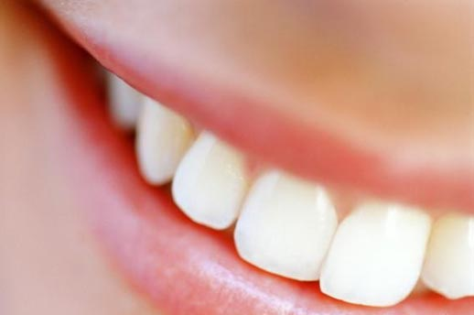

A way to communicate,
to watch from different points of view,
to meet and cooperate.

Eyes, hears, mouth:
the doors and windows of your heart:
print a nice smile on them!
...

Never too open, never too close.
Opening them, wide? Closing, barring them?
A windows with curtains and flowers?

A window with bars?
E
.

A way to communicate,
to watch from different points of view,
to meet and cooperate.

Eyes, hears, mouth:
the doors and windows of your heart:
print a nice smile on them!
...

Never too open, never too close.
Opening them, wide? Closing, barring them?
A windows with curtains and flowers?

A window with bars?
E
.

A way to communicate,
to watch from different points of view,
to meet and cooperate.

Eyes, hears, mouth:
the doors and windows of your heart:
print a nice smile on them!
...

Never too open, never too close.
Opening them, wide? Closing, barring them?
A windows with curtains and flowers?

A window with bars?
E
.

A way to communicate,
to watch from different points of view,
to meet and cooperate.

Eyes, hears, mouth:
the doors and windows of your heart:
print a nice smile on them!
...

Never too open, never too close.
Opening them, wide? Closing, barring them?
A windows with curtains and flowers?

A window with bars?
E
.

