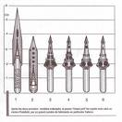

A pen-nib.

A small piece of metal.

It costs just a few cents.
If your are inattentive, if you dot not take care…

you forget it, it become rusty, alone, in one corner
you push it too hard and you bend it,

you drop it on its tip and you break it
it drops a large
stain

and it destroys the job of one whole day.
But you love it, he is docile, grateful…
S. Lucia
2006

www.legnani.eu/SLucia by joe


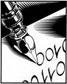

he dives for you in a sea made of black or coloured ink
he flows leaving a light track
a sharp straight mark,

or an elegant flourish
He reaches a far person.

He brings dramatic news or a love message.
Do not forget him, never leave him in a corner
let he run in the white field which he loves
or he moves heavy like a plough leaving a deep large trail
He opens your heart and gives it to the world…

…he is a loyal friend.
 

