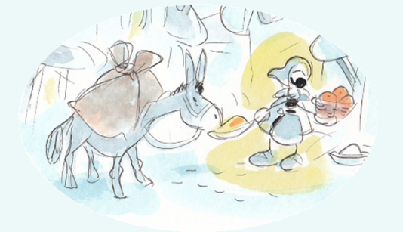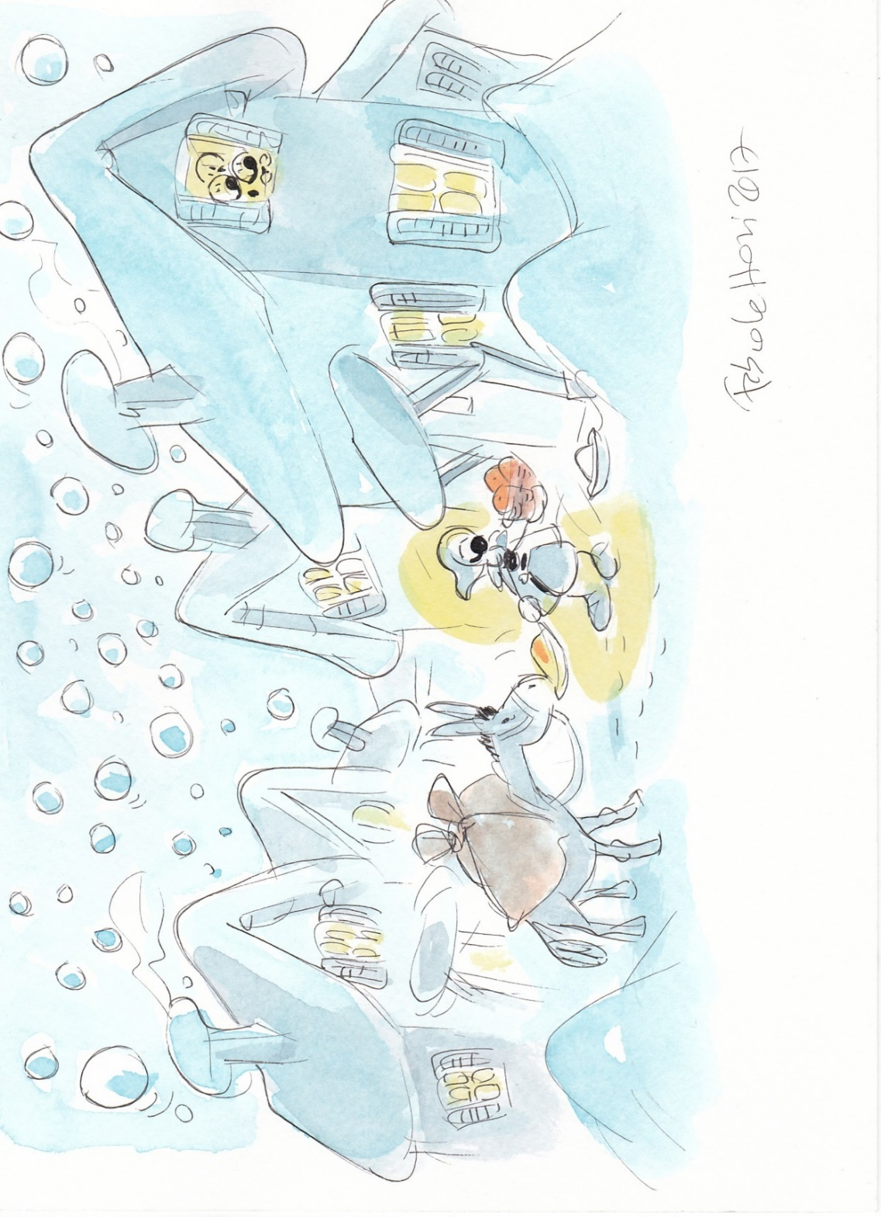

**S. Lucia 2023 by Joe ©**

**©©©**

**S. Lucia 2023 by Joe ©**

**©©©**

13 dicembre

*by joe ©*



*2023*

S. Lucia

**S. Lucia 2023 by Joe ©**

**©©©**